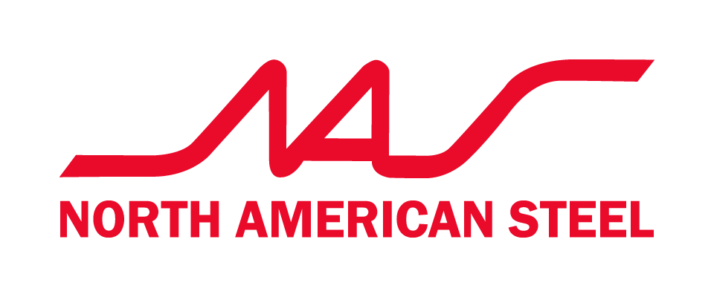

AODA Accessible Customer Service Feedback Form – Ontario

October, 2023
We welcome feedback on the accessibility of our goods, services, and facilities. Accessible formats and communication supports are available upon request to enable all customers to provide feedback in a manner that meets their needs. To request an alternate format or support, please contact 905-355-5444 ext.102 or email melissas@naseco.ca
If negative feedback or a complaint is received, the company takes all reasonable measures to resolve the issue to prevent future occurrences. Where the customer’s contact information has been provided, the company will respond to the complainant within ten business days to inform them of the measures that have been or will be taken.

Date: _________________________________

Were you satisfied with the accessibility of our service, goods, and facilities?

☐Yes
☐No
☐Somewhat

Why or why not?
________________________________________________________________________
________________________________________________________________________
________________________________________________________________________
Did you experience any barriers to accessing our goods, services, or facilities?

☐Yes
☐No
☐Somewhat

If yes or somewhat, please explain.
________________________________________________________________________
________________________________________________________________________
________________________________________________________________________

Do you have any recommendations to make accessing our goods, services, or facilities easier for people with disabilities?

☐Yes
☐No

If yes, please explain.
________________________________________________________________________________________________________________________________________________
________________________________________________________________________
Are you satisfied with the accessibility of our feedback process?

☐Yes
☐No
☐Somewhat

Why or why not?
________________________________________________________________________
________________________________________________________________________
________________________________________________________________________

Did you experience any barriers to providing feedback?

☐Yes
☐No
☐Somewhat

If yes or somewhat, please explain.
________________________________________________________________________
________________________________________________________________________
________________________________________________________________________

Additional comments
________________________________________________________________________
________________________________________________________________________
________________________________________________________________________

Customer Contact Information

Customers are invited to provide their contact information so that North American Steel can follow up with them regarding their feedback. This is entirely optional. If a customer chooses to provide their contact information, it will be used for the sole purpose of responding to their feedback.

Name: ______________________________

Preferred contact method. (Please check one)

☐E-mail

☐Phone

☐Other. Please specify: _________________

Contact information: (Please provide your contact information below)

